
Regulation:
A14
Sreenidhi Institute of Science and Technology
(An Autonomous Institution)
Code No: 4U104 Date :01-03-2016
M.Tech. I-Year I-Semester Examinations, Feb/March- 2016 (Supplementary)
ADVANCED DIGITAL SIGNAL PROCESSING (DSCE)

Time: 3 Hours Max.Marks:60

Note: No additional answer sheets will be provided.

Part - A Max.Marks:10

Answer all QUESTIONS. EACH QUESTION CARRIES 1 MARK.
1 Explain the importance of Levinson Durbin Algorithm.
2 Draw an 8-point DFT using Decimation in time algorithm for radix-4
3 Draw the block diagram of a Multirate signal processing system.
4 Differentiate between Chebyshev and Butterworth filters.
5 Distinguish forward and backward linear prediction algorithms.
6 Explain about Gibb's phenomenon.
7 List the properties of DFT.
8 Discuss the need of ant-aliasing filter before the down sampler in the implementation of decimator.
9 Specify the advantages of IIR filters.
10 Write properties of Linear Prediction Filters.
Part – B Max.Marks:50
ANSWER ANY FIVE QUESTIONS. EACH QUESTION CARRIES 10 MARKS.
1. a) Perform circular convolution for the given sequences x= { 1, 2, 3, 4), h= { 1, 2, - 1, 1) using DFT and IDFT method. 6M
b) Explain any one Linear filtering method based on DFT. 4M
2. a) Explain Split Radix Algorithm. 6M
b) Write about Chirp-Z Transform Algorithm, briefly. 4M
3. a) Design a Butterworth digital filter using the bilinear transformations, the specifications are given as below: With T=1 sec. 6M
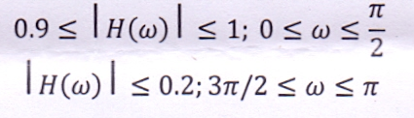
b) Determine the order of the Chebyshev filter for the following specifications: 4M
i) Maximum pass band ripple is ldB for 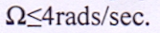
ii) Stop band attenuation is 40dB for
4. a) Design a low pass linear phase FIR filter for N=5 with the following parameters:
cut-off frequency=200Hz, and sampling frequency is 1000Hz. 6M
b) Draw the direct form structure of the FIR filter described by the transfer function 4M
5. a) State and prove identities associated with Interpolator in Multirate signal processing. 6M
b) Develop a Polyphase decomposition for the following transfer function: 4M
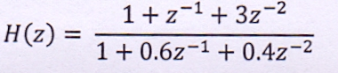
6. a) Describe the Wiener filtering for minimization of Mean Square error.
b) Explain about the optimal backward linear filtering.
7. Write short notes on any two of the following: All carries equal marks
a) Design of spectrally efficient OFDM systems.
b) Cascade structure used in the realization of digital filters.
c) Applications of Multirate signal processing.
-- 00 -- 00 –

